Tumbling Bay - Fish Pass Project
September 2018
Summary
The Tumbling Bay Fish Pass Project is an exciting initiative which is being led by the Environment Agency, and developed in consultation with Oxford City Council. The project aims to improve the local river habitat for fish and to improve the character of the Tumbling Bay area as a public open space.
If the project is approved, a new naturalistic flowing stream will be created on the north side of Tumbling Bay, providing a route for fish migration. In order to make space for the new channel, some of the existing scrub will be cleared either side of the new channel. In place of the scrub, the newly opened up land will be seeded with a native wildflower mix. This work will create an attractive new channel, bordered by riparian and bankside planting to create newly accessible space and valuable habitats for wildlife.

Background
The Bulstake Stream is a distributary of the Thames. It leaves the main River to the South West of Fiddlers Island and flows for approximately 2.5km before re-joining the Thames to the south of Osney Industrial Estate. The Bulstake Stream supports areas of good quality fish spawning and nursery habitat. Spawning habitat is in very short supply on the main River Thames because it is managed as a navigation and is, therefore, highly impounded, deep and slow flowing.
As part of the Oxford Flood Alleviation Scheme (FAS) the lower section of the Bulstake Stream will be isolated, and a new channel will connect the Bulstake Stream with the Hinksey Stream to create a new length of good quality habitat. A fish pass at Tumbling Bay will, therefore, complement the range of habitat improvement works being delivered through the Oxford FAS. Together, these projects, and ongoing work to deliver a bypass channel on the Seacourt Stream, will provide unimpeded routes for fish around Oxford for the first time in hundreds of years.
Fish such as chub, dace, and barbel spawn amongst well oxygenated gravelly substrate which is present on a number of sections of the Bulstake stream. However the channel is currently impacted by the two weirs associated with the historic bathing place at Tumbling Bay.
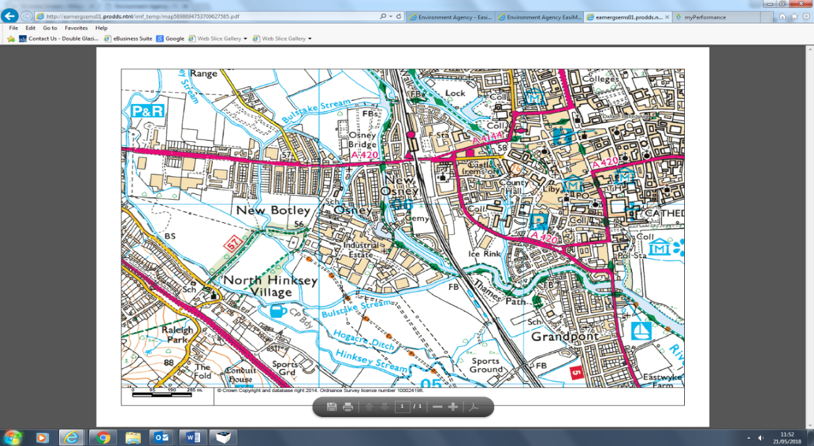
Tumbling Bay

Figure 1: The Bulstake Stream with Tumbling Bay marked
To facilitate fish migration past the weirs at Tumbling Bay a fish pass is required. It is the ambition of the Environment Agency to develop and deliver a fish pass solution at this site within this current financial year (2018/2019). However, if very wet weather is experienced later in the year, causing flooding and/or poor ground conditions, the project programme may get pushed back.
Project Aims
The project will:
- Provide a route for fish migration between the Bulstake Stream and the River Thames for a diverse range of fish species at their various stages of maturity.
- Create new spawning habitat within the Bulstake Stream.
- Create an aesthetically pleasing facility for fish passage that will complement and enhance the setting of Tumbling Bay.

The project design will also ensure that the fish pass does not:
- Pose a risk to public safety.
- Increase flood risk.
- Impact river levels for navigation or abstraction.
- Impact on the structure of Tumbling Bay
Project Constraints/Considerations
A number of potential constraints have been identified during the early stages of the project development. We are working with Oxford City Council to fully understand these constraints and to develop solutions:
- Trees: There are a number of mature trees on the site, including a large ash and a hornbeam. These trees add to the landscape value of the public space and it is, therefore, important to protect these trees. The new channel will be designed to achieve this. An onsite meeting with OCC's Tree Officer has confirmed that the proposed channel route will allow for both trees to be retained. This will be supported by a tree protection plan which is under development. One large willow tree will need to be removed to accommodate the new channel. This tree has been inspected for bats and has been classified as being of very low potential. One section of the tree will need to be 'soft felled' in order to mitigate for any remaining risk, and this will form part of the brief for the contractors undertaking the work.
- Heritage/ Archaeology: Tumbling Bay is of local heritage value and, following an internal screening by our in-house Archaeologists, a Desk Based Assessment (DBA) of the area has been commissioned. The scope for this DBA has been agreed by the City Archaeologist. This is being undertaken by Oxford Archaeology, and is near completion. This DBA will form part of a future planning application and any recommendations will be considered as part of the design.
- Wider Ecology: Ecological survey will be undertaken in order to determine impacts on local ecology and protected species. Water vole and otter surveys will be managed in-house by Environment Agency Ecologists. A bat survey has been completed by BSG Ecology. The report for this work is due soon, but initial results show that the project will not negatively impact upon bats.

Preferred Option
The initial option appraisal and ecosystem service assessment has highlighted that the preferred option for the site is a natural bypass channel running between the River Thames and the Bulstake Stream downstream of the two weirs (Figure 2). This channel will be approximately 185m in length and will support a 1:140 gradient and will be designed to look like a natural stream.
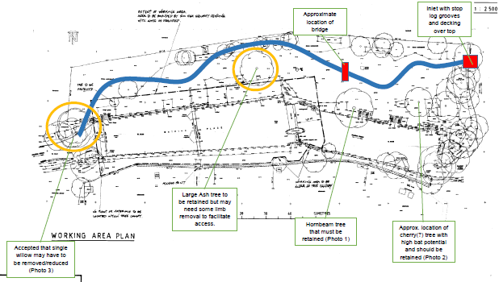

Figure 2: Indicative route of proposed bypass channel (marked in red).

This option not only provides a technically viable solution, but also offers a range of additional benefits which are listed below (details of other options considered, and ruled out, can be provided on request):
- A bypass channel allows a more diverse range of fish to migrate upstream in comparison to a technical fish pass which only facilitates fish passage for larger coarse fish and salmonids.
- A naturalistic bypass channel can also be designed to create good quality in-river habitat which will, in turn, benefit fish and invertebrate populations.
- The bypass channel will include bridges and walkways which will facilitate public use and enjoyment of the space. In fact, it could become an attractive feature to be enjoyed by the public in the summer months.
- The bypass channel will not impact upon the historic bathing facility and will not alter this historically significant part of the public open space.
- The flow passing through Tumbling Bay will be reduced, but this will also reduce the rate of sedimentation.

Supporting Projects - Case studies
Hinksey Fish Pass Project
Hinksey Fish Pass Project was completed within Oxford City in 2012. This project saw the creation of a new 100m long stream which provides a route for fish around a large weir structure.  The new channel has developed well. It supports a diverse range of marginal plants, and invertebrates (including damselflies and dragonflies), and has been proven as a route for fish migration.  This channel takes more flow than is proposed for the Tumbling Bay Fish Pass. However it demonstrates that the technique works to provide fish passage and to create new habitats. | 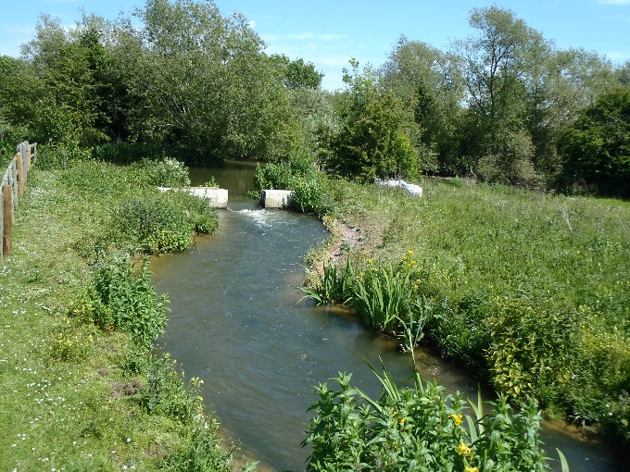  Hinksey Bypass Channel in 2015.

Seacourt Stream Fish Pass Project

Seacourt Stream Fish Pass Project is currently under development. The project is being led by Thames Water, in consultation with the EA, as part of their AMP6 investment programme.  This project will provide a route for fish passage on another of the Oxford Water Courses and will complement the proposed work at Tumbling Bay.  This project will provide fish passage into the River Thames upstream of Kings Lock, bypassing all of the online structures through Oxford. | 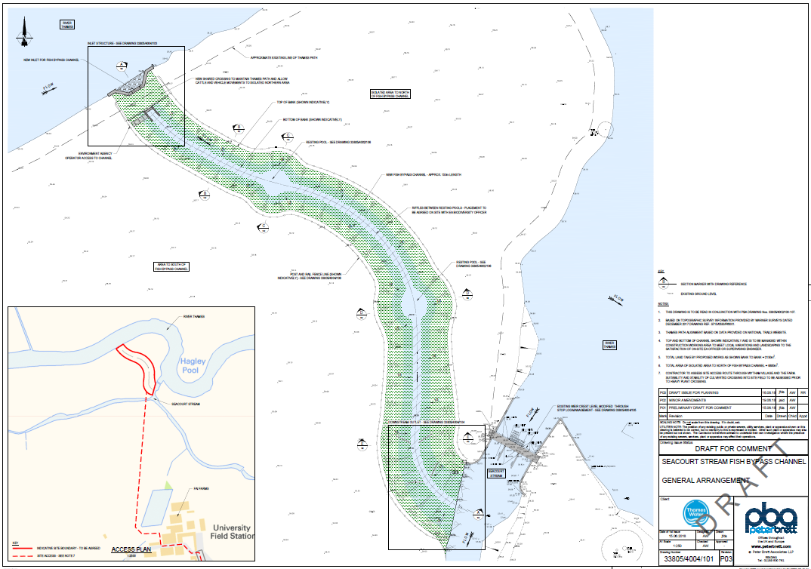  Plans for Seacourt Stream Bypass Channel
All in all, the work completed at Hinksey, the planned work through Oxford FAS, Tumbling Bay, and Seacourt Stream, unimpeded fish passage will be possible around Oxford for the first time in hundreds of years!

